Java String compare

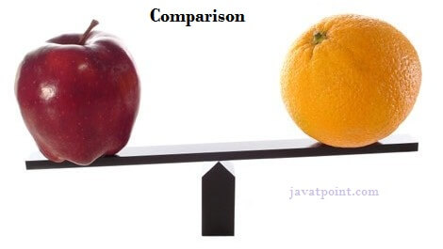

We can compare string in java on the basis of content and reference.

It is used in **authentication** (by equals() method), **sorting** (by compareTo() method), **reference matching** (by == operator) etc.

There are three ways to compare string in java:

1. By equals() method
2. By = = operator
3. By compareTo() method

1) String compare by equals() method

The String equals() method compares the original content of the string. It compares values of string for equality. String class provides two methods:

* **public boolean equals(Object another)** compares this string to the specified object.
* **public boolean equalsIgnoreCase(String another)** compares this String to another string, ignoring case.

1. **class** Teststringcomparison1{
2. **public** **static** **void** main(String args[]){
3. String s1="Sachin";
4. String s2="Sachin";
5. String s3=**new** String("Sachin");
6. String s4="Saurav";
7. System.out.println(s1.equals(s2));//true
8. System.out.println(s1.equals(s3));//true
9. System.out.println(s1.equals(s4));//false
10. }
11. }

[**Test it Now**](http://www.javatpoint.com/opr/test.jsp?filename=Teststringcomparison1)

Output:true

true

false

1. **class** Teststringcomparison2{
2. **public** **static** **void** main(String args[]){
3. String s1="Sachin";
4. String s2="SACHIN";
6. System.out.println(s1.equals(s2));//false
7. System.out.println(s1.equalsIgnoreCase(s2));//true
8. }
9. }

[**Test it Now**](http://www.javatpoint.com/opr/test.jsp?filename=Teststringcomparison2)

Output:

false

true

[Click here for more about equals() method](https://www.javatpoint.com/java-string-equals)

2) String compare by == operator

The = = operator compares references not values.

1. **class** Teststringcomparison3{
2. **public** **static** **void** main(String args[]){
3. String s1="Sachin";
4. String s2="Sachin";
5. String s3=**new** String("Sachin");
6. System.out.println(s1==s2);//true (because both refer to same instance)
7. System.out.println(s1==s3);//false(because s3 refers to instance created in nonpool)
8. }
9. }

**[Test it Now](http://www.javatpoint.com/opr/test.jsp?filename=Teststringcomparison3" \t "_blank)**

Output:true

false

3) String compare by compareTo() method

The String compareTo() method compares values lexicographically and returns an integer value that describes if first string is less than, equal to or greater than second string.

Suppose s1 and s2 are two string variables. If:

* **s1 == s2** :0
* **s1 > s2**  :positive value
* **s1 < s2**  :negative value

1. **class** Teststringcomparison4{
2. **public** **static** **void** main(String args[]){
3. String s1="Sachin";
4. String s2="Sachin";
5. String s3="Ratan";
6. System.out.println(s1.compareTo(s2));//0
7. System.out.println(s1.compareTo(s3));//1(because s1>s3)
8. System.out.println(s3.compareTo(s1));//-1(because s3 < s1 )
9. }
10. }

**[Test it Now](http://www.javatpoint.com/opr/test.jsp?filename=Teststringcomparison4" \t "_blank)**

Output:0

1

-1

[Click me for more about compareTo() method](https://www.javatpoint.com/java-string-compareto)